Press Release

Aquaintech Inc. (AITI) was the first company to successfully develop and market Bacillus spore tablets for use in aquaculture. PRO4000X, our lead tableted product, is widely used in hatcheries, RAS systems, shrimp and fishponds, reservoirs, and discharge and intake canals. PRO4000X was designed to target pond bottoms. AITI is pleased to announce the addition of the TWC Bio-Block (TBB) to its product line targeted for the water column.

TBBs are engineered to enhance the in-situ performance of probiotic bacteria. Each block contains a large internal surface area that allows bacteria to colonize, form biofilms and excrete a variety of enzymes and anti-microbial substances. Studies have shown that the blocks hold large numbers of viable bacteria. They can be placed in both shallow and deep ponds, flowing bodies of water such as rivers, as well as in cages to improve water quality with beneficial impacts on productivity.

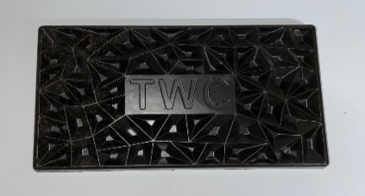

Bacillus species thrive in these blocks. They produce a potent array of enzymes that degrade organic matter and can favorably impact the microbiome in fish species and crustaceans. Increasing the levels of enzyme production has a number of positive benefits. By impacting nutrient loads they impact water quality and can alter the microbiome reducing the numbers of some potential pathogens.

Another important factor to consider is the presence of natural oils, a result of their presence in feed and feces. Elevated oil levels can create high surface tensions which can decrease oxygen levels in the water. The Bacillus in the TWC Block convert these natural oils into amino acids. This reduces the surface tension, which allows for oxygen to penetrate the body of water providing the beneficial bacteria a boost to complete the nutrient cycle.

Contact us for more information about the TWC block or how you can benefit from working with us. You can call us at 425-787-5218, E-mail/WhatsApp us at sgnewm@aqua-in-tech.com/1-425-239-7682 and/or mrnewm@aqua-in-tech.com/1-206-963-4274 or visit our website at www.aqua-in-tech.com. Distributor inquiries welcome.

